**Mollusca**

The phylum Mollusca is one of the largest of the invertebrate clades, both in the size of certain species and the number of species, which have been described. Early mollusks were abundant in Cambrian seas and the long history of the group is reflected today in the variation among Molluscan types. This variation also attests to the success and plasticity of the basic Molluscan body plan.

Background

The basic molluscan body plan is bilaterally symmetrical, unsegmented, and coelomate and the body is divided into a ventral muscular foot, a dorsal visceral mass, and a **mantle** of epithelium and other tissue which encloses the dorsal surface of the body. The cavity between the mantle and visceral mass is termed the **mantle cavity**. The visceral mass is provided with a blood circulatory system generally containing the oxygen carrying copper pigment haemocyanin, a variably specialized and cephalized nervous system with ganglia and ventral nerve cords, a well-developed excretory system, and a distinct reproductive system. The mantle cavity generally houses an efficient respiratory system. As will be seen in today's and next week’s laboratory, however, among the molluscan clades (classes) almost every one of the organ systems mentioned above shows a wide spectrum of variation.

Mollusks apparently arose as creeping types, probably living on hard surfaces and scraping their food from the substrate by means of a unique organ, the **radula**, which is found in all modern clades except the Bivalvia (Pelecypoda). Bivalves have extensively modified their gills (**ctenidia**) for filtering particulate food from the water column. The molluscs are closely related to the annelids. This affinity is seen in the similar developmental patterns within the two groups, the **trochophore larva**, and the possible vestiges of segmentation seen in some of the primitive molluscs.

**We will use three basic model organisms. Gastropods are readily available. We can easily work with them and see basic variation within this large clade in relation to lifestyle. The squid because frozen specimens are large and so easily dissected will serve as our model for Cephalopods. Everyone should also dissect one of the bivalves available and compare their anatomy to that of the squid and snail (via diagrams as dissecting a gastropod can be a very time consuming experience, requiring a lot of patience). Dissections will be done next week.**

**Observations on gastropods (Gastropoda)**

### **1. Snails**

The gastropods differ from other ancestors in having an enlarged head and visceral mass, in most cases a logarithmically spiraled shell, and a visceral mass that has undergone a 180° rotation during development (**torsion**), so that the gills and anus are located on the anterior end of the snail.

Locomotion

Locomotion in most gastropods is accomplished by muscular contractions of the foot aided by mucus secretion. Exceptions to this general pattern include swimming gastropods and gastropods that use cilia to locomote. In gastropods that move by the muscle/mucus method, there are two specific ways by which movement is achieved: 1) **direct muscular waves** where the posterior edge of the foot is lifted, moved forward and then this advancing wave is propagated forward and 2) **retrograde muscular waves** where the anterior end of the foot is stretched and attached and the advancing wave is propagated backwards.

a**. Watch your snails crawl across a glass surface. Observe and describe the motion of the foot. Time the snail as it moves along the surface. Calculate average speed. Calculate feet per minute and miles per hour.**

Some convenient conversions:

cm/min x 1.97 = feet/hour; ft/min x 0.0114 = mi/hr;

cm/min x 0.6 = meters/hr.

**b. Feeding: action of the radula.**

**Sandwiches have been prepared, or you will prepare, that have fish or shrimp embedded in the middle of two slides. Follow teaching assistant instructions as to how to prepare sandwiches. Allow the snails to start feeding on the sandwich and the gently place the snails + sandwich so you can observe the radula. Describe feeding by each species and try to get a photograph or video of the radula if you can. Count the strokes of the radula per minute if possible**.

**2. Limpets**

**Limpets are gastropods that superficially resemble chitons and monoplacophorans.**

Limpets have a distinctive, oval shaped shell, with the peak more-or-less near the center, their strong muscular foot can grab small imperfections in the rock surface, and grasp very strongly. In all true limpets the mantle has developed a considerable overhang, so that there is a groove which runs around the inside of the shell called the **mantle groove**. It is through this groove that the water current flows.

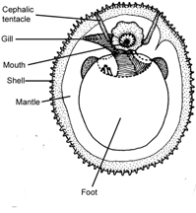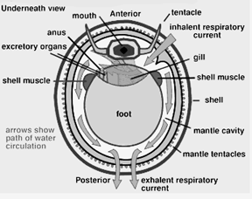

Limpets superficially resemble monoplacophora, the most primitive clade of Mollusca.

a. Take a photograph of the dossal surface of your limpet, using the diagrams above to identify important structures. Then compare it to the diagram of a monoplacophoran provided. **Compare the “head” and placement of gills (ctenedia) in the two groups.** We will discuss the Monoplacophora in lecture.

Monoplacophoran: ventral view--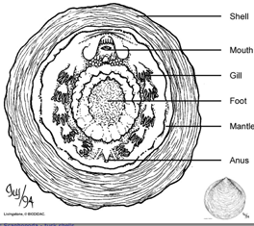

**3. Polyplacophora or chitins**

Their body form is specially adapted for the rough conditions associated with the intertidal zone of the oceans. When chitons are active they slowly creep across the rocks feeding on encrusted algae and other organic debris. If threatened they can roll up into a ball surrounded by the protective armor of their shell.

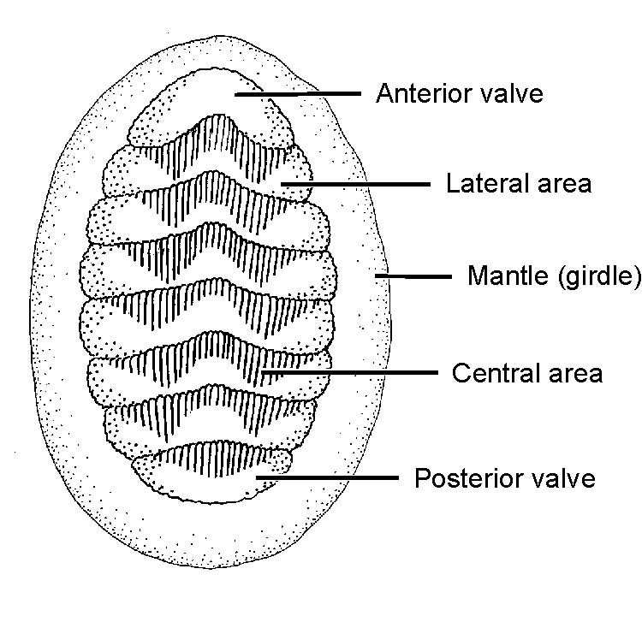

Obtain a chiton. Count the number of dorsal valves. Around the edge of the chiton is a muscular **girdle** with lateral edges of the eight valves embedded in it. The girdle is an exposed part of the **mantle**, the rest is underneath the plates and, depending on the specimen, you will be able to see the needle-like **calcareous spicules** embedded there. The most primitive molluscs didn’t have a shell and were protected by spicules much like those around the edge of the chiton.

Turn you animal over and observe the ventral surface.

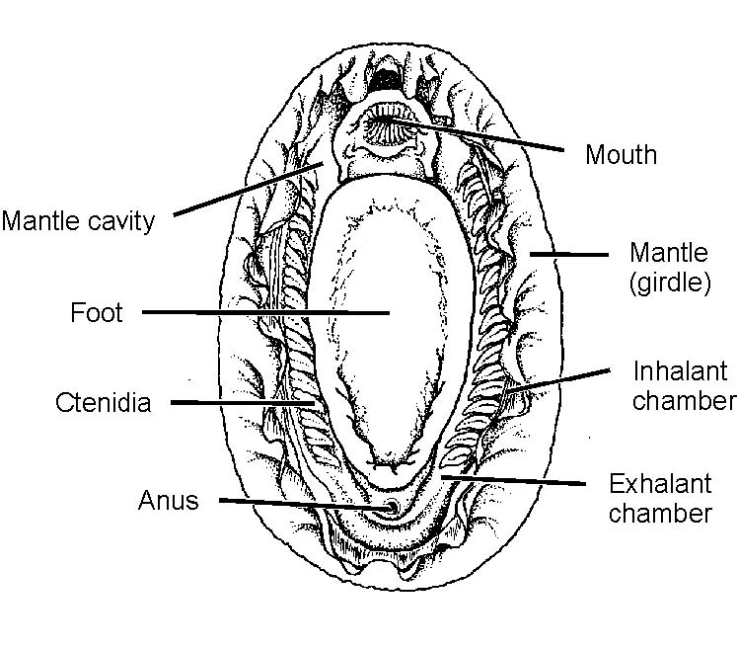

The large oval **foot** dominates the ventral surface of a chiton and along its lateral edges are the **mantle cavity** includes grooves formed from a trough between the foot on the inside and the fleshy girdle. Inside the mantle cavity you can see the multiple **ctenidia** used for gas exchange. The **mouth** is easy to see at the anterior end but there are neither eyes nor tentacles associated with it. At the opposite end, the **anus** is located on the roof of the mantle cavity, on the tip of a small papillae. C**ilia** on the surface of the ctendia propel water through the mantle cavity pulling it in at the anterior end surrounding the mouth, down the two mantle cavities on each side, and over the ctenidia. At the back the left and right mantle cavities fuse to form a single **exhalent canal** where the anal opening is located. If you look closely in the region of the last few ctenidia you may also be able to see **nephridiopores** or **gonopores** that open into this posterior part of the mantle cavity.

**Take a photograph of the ventral surface and label the ctenidia and mouth at least. What else you can see? If you are simply viewing specimens in the aquarium, please describe and compare their dorsal and ventral surfaces to that of snails and limpets.**

.